1. **Perform basic Image Handling and processing operations on the image. Read an image in python and convert an image to grayscale.**

**Aim:**

To perform basic operations to read image and convert to grayscale using python

**Code:**

import cv2

image = cv2.imread(r'C:\Users\prith\Pictures\Saved Pictures\cvimage.jpg')

if image is None:

print("Error: Image not found.")

else:

grayscale_image = cv2.cvtColor(image, cv2.COLOR_BGR2GRAY)

cv2.imshow('Original Image', image)

cv2.imshow('Grayscale Image', grayscale_image)

cv2.waitKey(0)

cv2.destroyAllWindows()

**Input:**

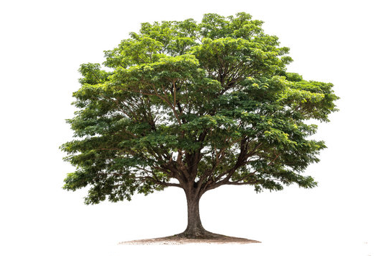

**Output:**

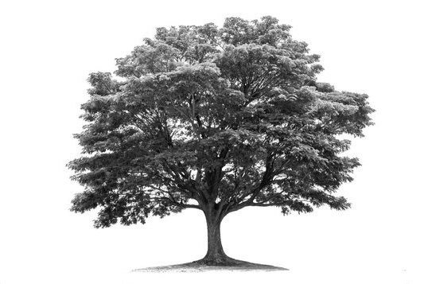

**Result:**

Gray scale conversion using python is successfully implemented.